**Project Team 27**

Sprint #2

Week #3

Team Member Name – Swapnil Makarand Joshi

What I did since the last week scrum?

1. Development of GUI element

What I plan to do next week?

1. Finish development of GUI element and integration between them
2. Start integration and testing of game

What blockers I have?

None

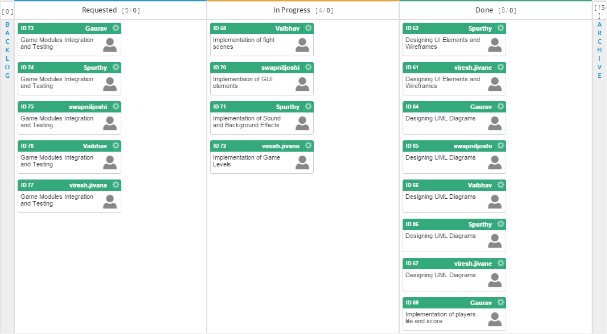

Task board in Kanbanize

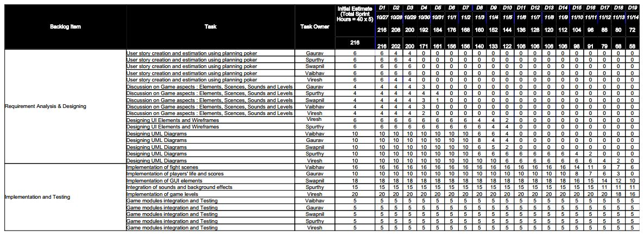

Weekly Standup Report

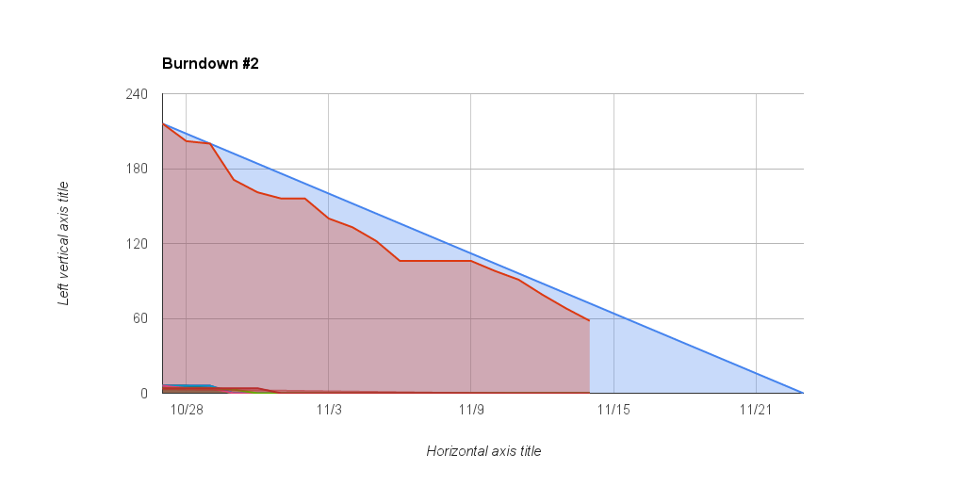

Burndown Chart